Creating Mater node ::

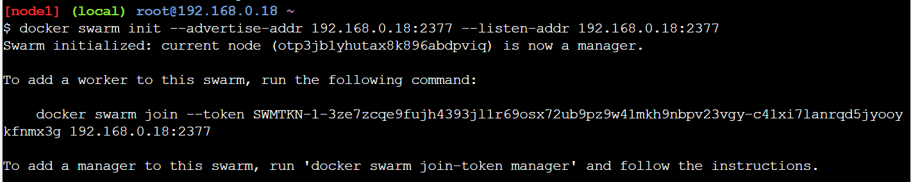

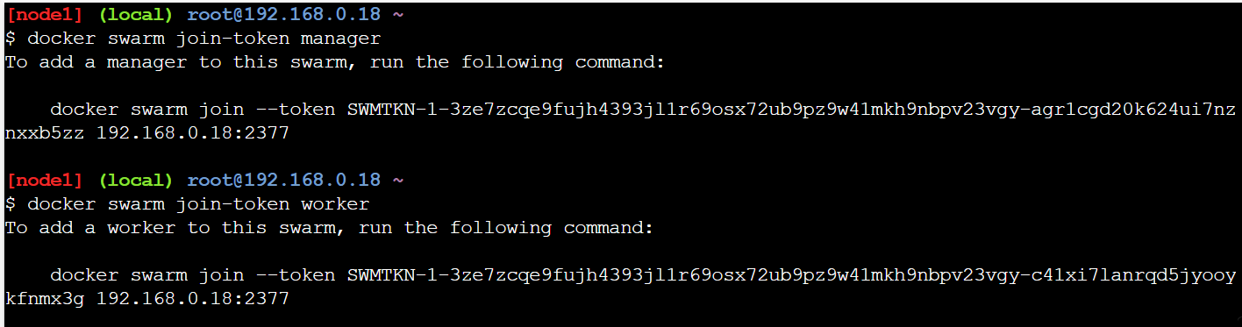

Worker Node 1 ::

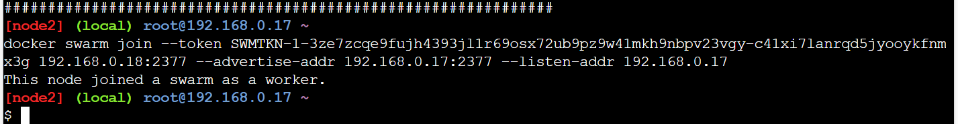

Worker Node 2 ::

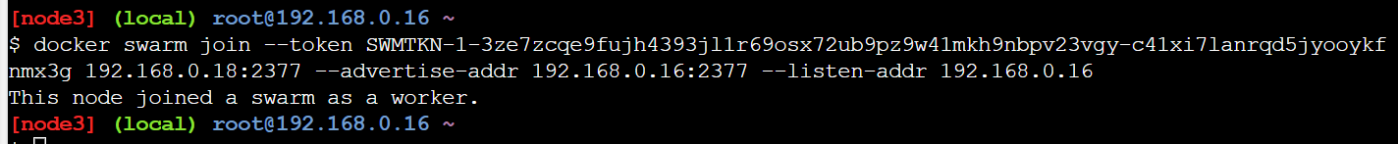

List Of Nodes joined to cluster ::

